Lesson 1 Introduction to Estimation

[1. Sebastian Introduction](https://classroom.udacity.com/nanodegrees/nd787/parts/a1505b23-c1aa-4bc6-a94c-d44d062d0209/modules/19b5af05-2ec7-491a-94db-1befc15d07c0/lessons/0aad84d9-ec84-42b6-8ed8-10d770055da4/concepts/41d169b6-f2b8-4b50-8448-9792ec934250)

<https://www.youtube.com/watch?v=feIE-SVBCjA>

[2. Welcome Back](https://classroom.udacity.com/nanodegrees/nd787/parts/a1505b23-c1aa-4bc6-a94c-d44d062d0209/modules/19b5af05-2ec7-491a-94db-1befc15d07c0/lessons/0aad84d9-ec84-42b6-8ed8-10d770055da4/concepts/4c2241b3-10d8-4b5f-a44a-5e56c2e2c21f)

<https://www.youtube.com/watch?v=C04K4pvkbas>

[3. Intro to Estimation](https://classroom.udacity.com/nanodegrees/nd787/parts/a1505b23-c1aa-4bc6-a94c-d44d062d0209/modules/19b5af05-2ec7-491a-94db-1befc15d07c0/lessons/0aad84d9-ec84-42b6-8ed8-10d770055da4/concepts/af6662d3-4d74-43b3-ac9b-d17f94a13484)

<https://www.youtube.com/watch?time_continue=3&v=qQi-9ly0RXg>

[4. Review of Discrete Probability](https://classroom.udacity.com/nanodegrees/nd787/parts/a1505b23-c1aa-4bc6-a94c-d44d062d0209/modules/19b5af05-2ec7-491a-94db-1befc15d07c0/lessons/0aad84d9-ec84-42b6-8ed8-10d770055da4/concepts/4546b151-e032-4782-b98e-c757d10fcb57)

<https://www.youtube.com/watch?v=qeU6v66-uKk>

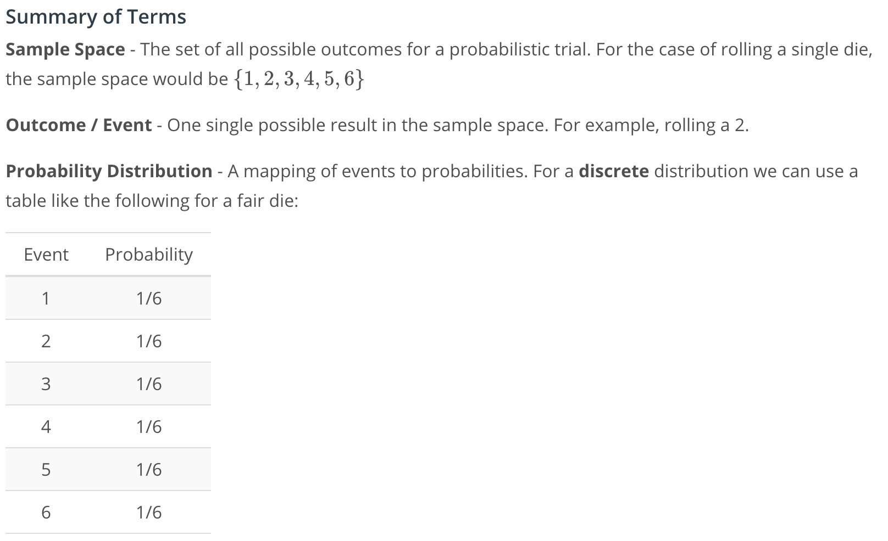

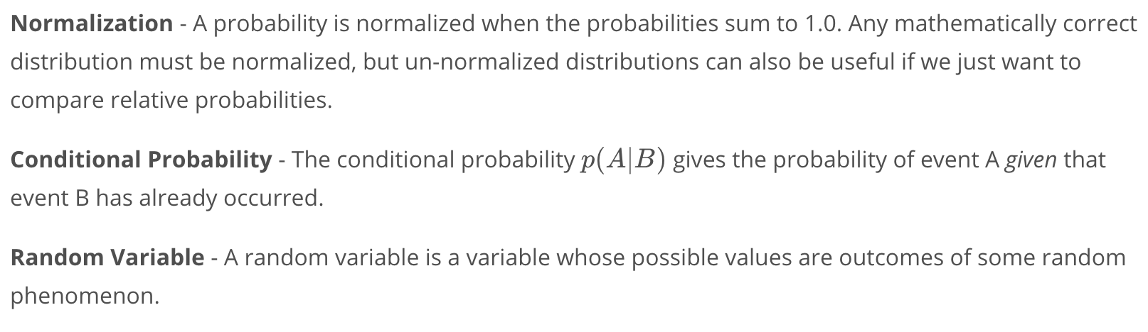

[5. Expected Value](https://classroom.udacity.com/nanodegrees/nd787/parts/a1505b23-c1aa-4bc6-a94c-d44d062d0209/modules/19b5af05-2ec7-491a-94db-1befc15d07c0/lessons/0aad84d9-ec84-42b6-8ed8-10d770055da4/concepts/3e39c4a6-154c-4195-aac6-a445d97063fc)

<https://www.youtube.com/watch?v=YqrPR1GnMoE>

[6. Variance](https://classroom.udacity.com/nanodegrees/nd787/parts/a1505b23-c1aa-4bc6-a94c-d44d062d0209/modules/19b5af05-2ec7-491a-94db-1befc15d07c0/lessons/0aad84d9-ec84-42b6-8ed8-10d770055da4/concepts/6e673dfc-6bcd-4c34-b77e-b75e03ac33c0)

<https://www.youtube.com/watch?v=79A0nWd0goY>

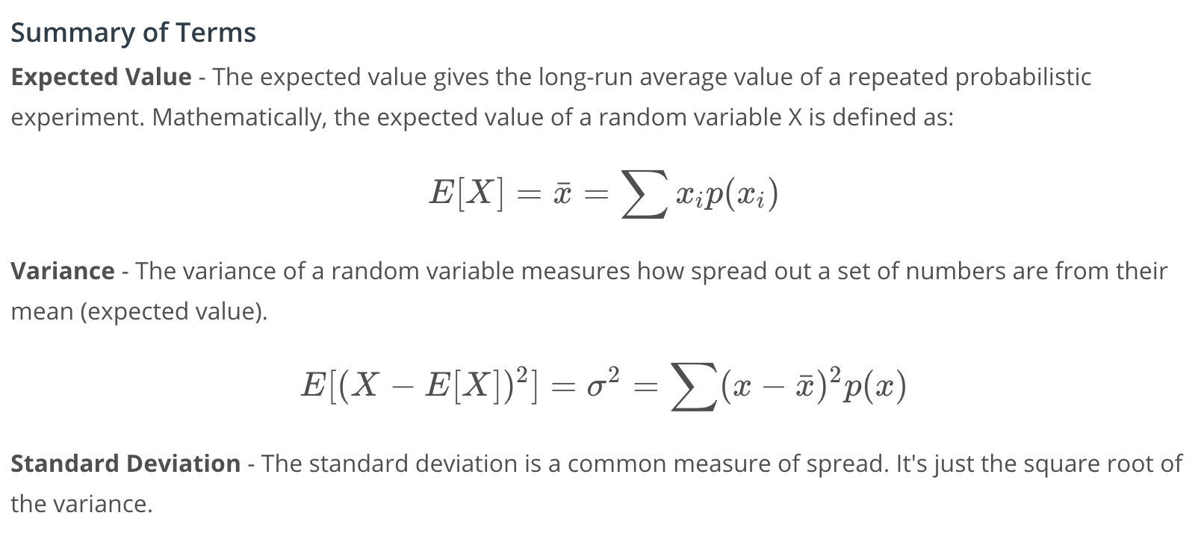

[7. Playing with Probabilities Notebook](https://classroom.udacity.com/nanodegrees/nd787/parts/a1505b23-c1aa-4bc6-a94c-d44d062d0209/modules/19b5af05-2ec7-491a-94db-1befc15d07c0/lessons/0aad84d9-ec84-42b6-8ed8-10d770055da4/concepts/fa2bab45-0e50-4cc3-b678-8efc9c98771f)

[Expected Value vs Variance.ipynb](https://view11b9dedb.udacity-student-workspaces.com/notebooks/Expected%20Value%20vs%20Variance.ipynb)

[8. Probability Density Functions](https://classroom.udacity.com/nanodegrees/nd787/parts/a1505b23-c1aa-4bc6-a94c-d44d062d0209/modules/19b5af05-2ec7-491a-94db-1befc15d07c0/lessons/0aad84d9-ec84-42b6-8ed8-10d770055da4/concepts/0cc2026f-1ca5-4ccc-8782-7da2012af09a)

<https://www.youtube.com/watch?v=lmkpfbpe9LQ>

[9. Uniform Distribution Notebook](https://classroom.udacity.com/nanodegrees/nd787/parts/a1505b23-c1aa-4bc6-a94c-d44d062d0209/modules/19b5af05-2ec7-491a-94db-1befc15d07c0/lessons/0aad84d9-ec84-42b6-8ed8-10d770055da4/concepts/043db31e-d9dc-4f6b-b14e-b268e7c03d77)

[Uniform Distribution.ipynb](https://view11b9dedb.udacity-student-workspaces.com/notebooks/Uniform%20Distribution.ipynb)

[10. Uniform and Gaussian Distributions](https://classroom.udacity.com/nanodegrees/nd787/parts/a1505b23-c1aa-4bc6-a94c-d44d062d0209/modules/19b5af05-2ec7-491a-94db-1befc15d07c0/lessons/0aad84d9-ec84-42b6-8ed8-10d770055da4/concepts/5c926871-8e3e-44ea-acd9-fd8a416aa8cd)

<https://www.youtube.com/watch?v=hK-6jz5ETHI>

### **What about flying cars?**

What does all of this have to do with flying cars? A lot!

Sensors, for example, are imperfect. If I am 1 meter away from a wall and I point my range finder at that wall, I'm likely to get measurements that are slightly different than 1 meter. I might get 0.992... then 1.001... etc...

These measurements are generally centered on the true value of the distance (in this case 1 meter) but they have "Gaussian Noise" added on as well. As you just saw, a Gaussian random variable is parameterized by the mean, \mu*μ*, and variance \sigma^2*σ*2.

A good sensor will have a small variance. A bad sensor will have a large variance. Either way, before we put a sensor on our drone we need to know, actually we need to **estimate**, what this variance is.

[11. Estimating Parameters from Data](https://classroom.udacity.com/nanodegrees/nd787/parts/a1505b23-c1aa-4bc6-a94c-d44d062d0209/modules/19b5af05-2ec7-491a-94db-1befc15d07c0/lessons/0aad84d9-ec84-42b6-8ed8-10d770055da4/concepts/b4aa2d8e-d72d-495f-b536-23399e2b8ab2)

<https://www.youtube.com/watch?time_continue=3&v=NTeLymqjPWU>

[12. Multivariate Distributions](https://classroom.udacity.com/nanodegrees/nd787/parts/a1505b23-c1aa-4bc6-a94c-d44d062d0209/modules/19b5af05-2ec7-491a-94db-1befc15d07c0/lessons/0aad84d9-ec84-42b6-8ed8-10d770055da4/concepts/fc373fc5-b445-4152-99b0-4a338839c293)

<https://www.youtube.com/watch?v=YmeaZcqfTK0>

[13. 2D Gaussian Notebook](https://classroom.udacity.com/nanodegrees/nd787/parts/a1505b23-c1aa-4bc6-a94c-d44d062d0209/modules/19b5af05-2ec7-491a-94db-1befc15d07c0/lessons/0aad84d9-ec84-42b6-8ed8-10d770055da4/concepts/9d40b1e0-7f58-4938-a9ab-019e564de950)

[2D-Gaussian.ipynb](https://view6b17b223.udacity-student-workspaces.com/notebooks/2D-Gaussian.ipynb)

[14. Joint and Marginal Distributions](https://classroom.udacity.com/nanodegrees/nd787/parts/a1505b23-c1aa-4bc6-a94c-d44d062d0209/modules/19b5af05-2ec7-491a-94db-1befc15d07c0/lessons/0aad84d9-ec84-42b6-8ed8-10d770055da4/concepts/a9425b7e-9b7d-4727-b17e-cdb475f1ad57)

<https://www.youtube.com/watch?v=Sm0Jv3lilQo>

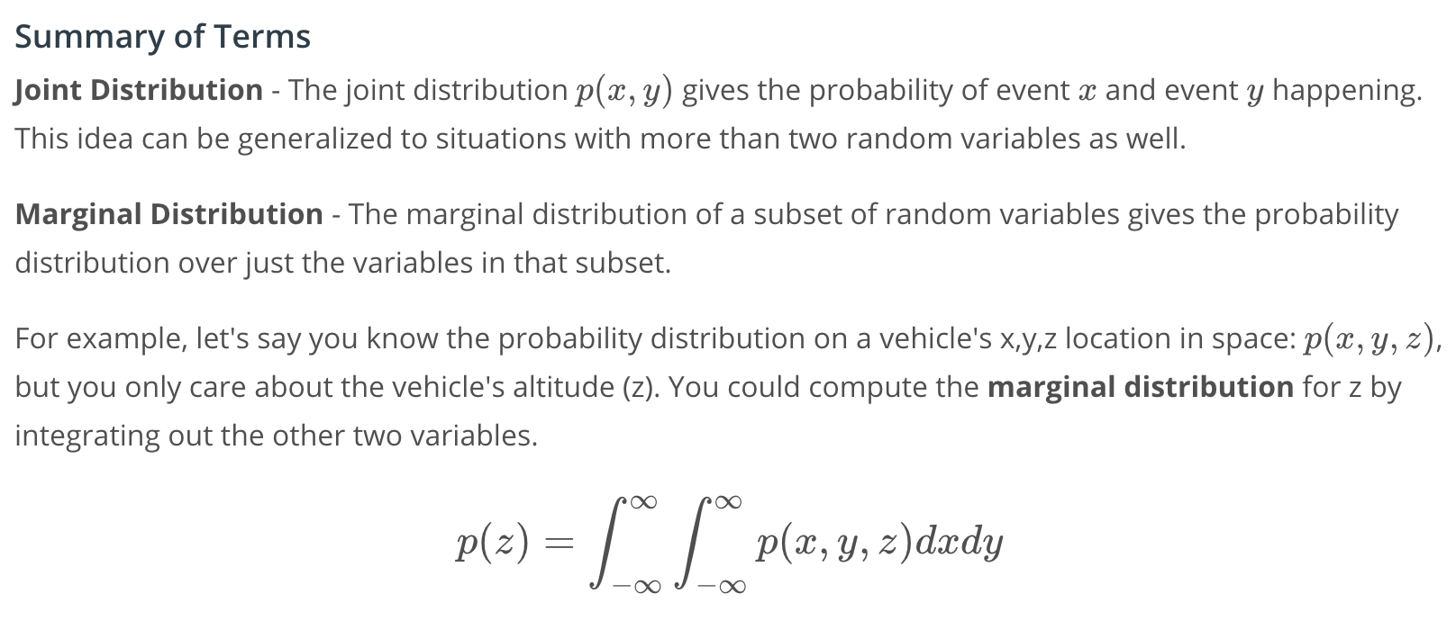

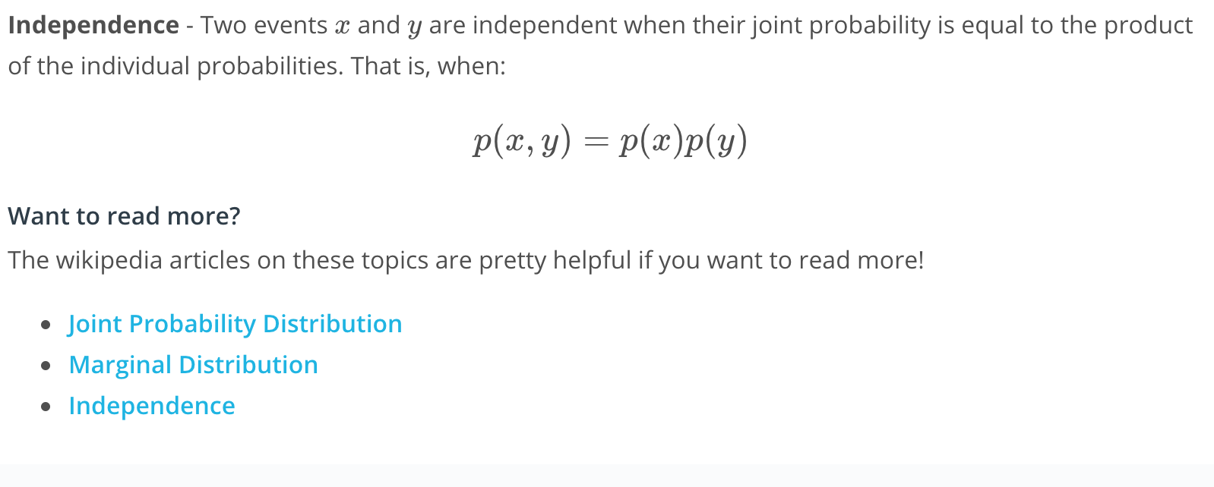

* [Joint Probability Distribution](https://en.wikipedia.org/wiki/Joint_probability_distribution)
* [Marginal Distribution](https://en.wikipedia.org/wiki/Marginal_distribution)
* [Independence](https://bit.ly/2HUxThg)

[15. Correlation and Independence](https://classroom.udacity.com/nanodegrees/nd787/parts/a1505b23-c1aa-4bc6-a94c-d44d062d0209/modules/19b5af05-2ec7-491a-94db-1befc15d07c0/lessons/0aad84d9-ec84-42b6-8ed8-10d770055da4/concepts/081b3de2-fa03-4876-85b9-e4fca692d32e)

<https://www.youtube.com/watch?v=gZIjyw62RdA>

### **Summary of New Terms**

**Correlation**: When two random variables are correlated, knowledge of one provides some information about the other. For example, the position of a vehicle **now** and the position of a vehicle in **one second**are correlated random variables: knowledge of one should give me some insight into the value of the other.

The **Pearson correlation coefficient** is one way of quantifying this relationship.

**Covariance**: Covariance is related to correlation. It is a measure of the *joint variability* of two random variables. If one variable tends to be big when the other is big, then the covariance is positive. The correlation coefficient is simply the normalized version of the covariance.

#### **Additional Resources**

Again, the wikipedia articles on these topics are generally thorough and well-explained.

* [Correlation](https://en.wikipedia.org/wiki/Correlation_and_dependence)
* [Pearson Correlation Coefficient](https://en.wikipedia.org/wiki/Pearson_correlation_coefficient)
* [Covariance](https://en.wikipedia.org/wiki/Covariance)

[16. Conditional Distributions](https://classroom.udacity.com/nanodegrees/nd787/parts/a1505b23-c1aa-4bc6-a94c-d44d062d0209/modules/19b5af05-2ec7-491a-94db-1befc15d07c0/lessons/0aad84d9-ec84-42b6-8ed8-10d770055da4/concepts/e0827354-a5ec-4dae-9cd0-da16fc1bca87)

<https://www.youtube.com/watch?v=nxDCf_vMXms>

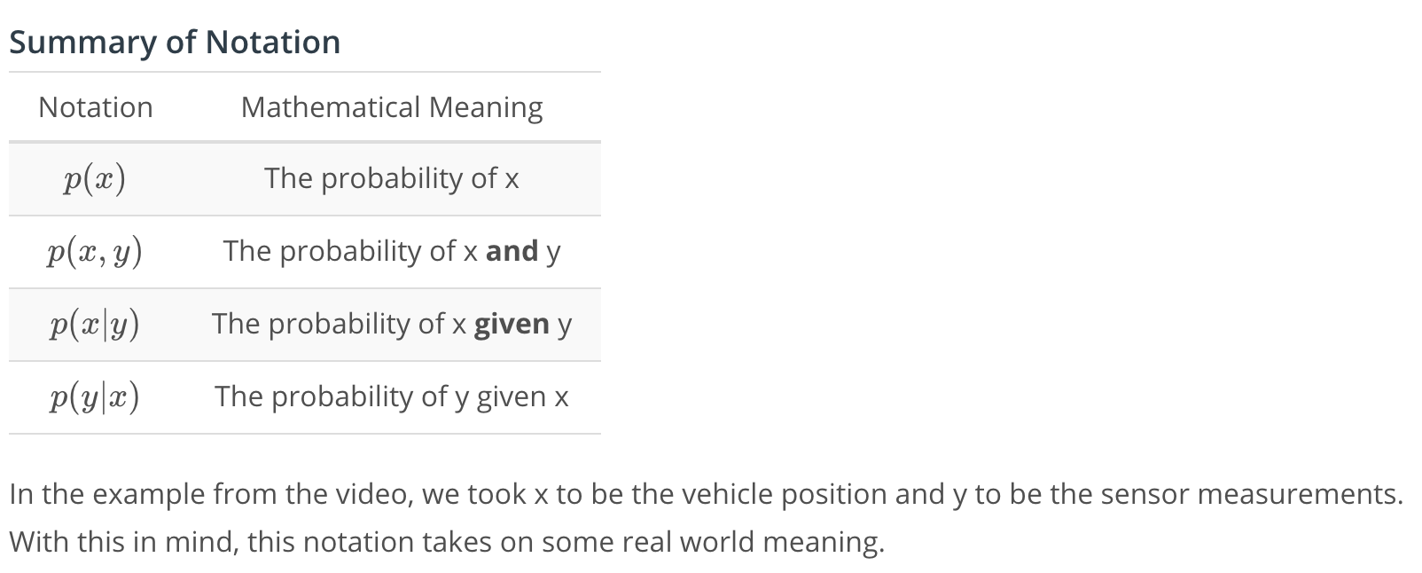

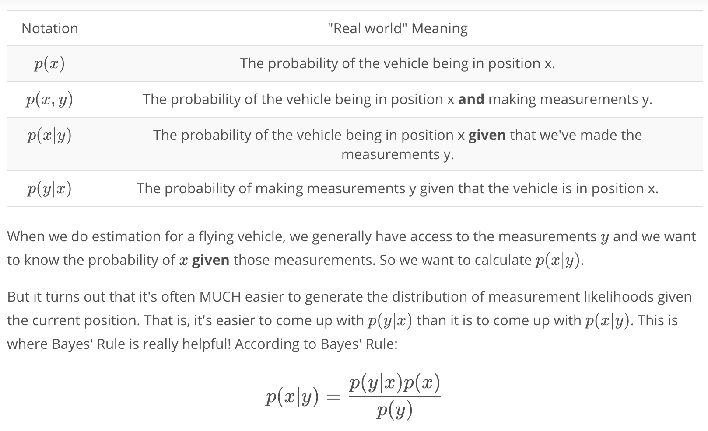

[17. Applying Bayes' Rule](https://classroom.udacity.com/nanodegrees/nd787/parts/a1505b23-c1aa-4bc6-a94c-d44d062d0209/modules/19b5af05-2ec7-491a-94db-1befc15d07c0/lessons/0aad84d9-ec84-42b6-8ed8-10d770055da4/concepts/2699c77b-78f0-4eeb-9005-1af8f90fe652)

<https://www.youtube.com/watch?v=R6S8VnN2CkA>

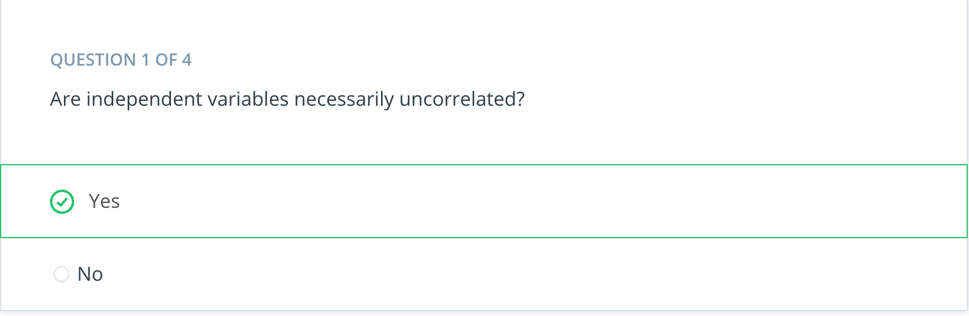

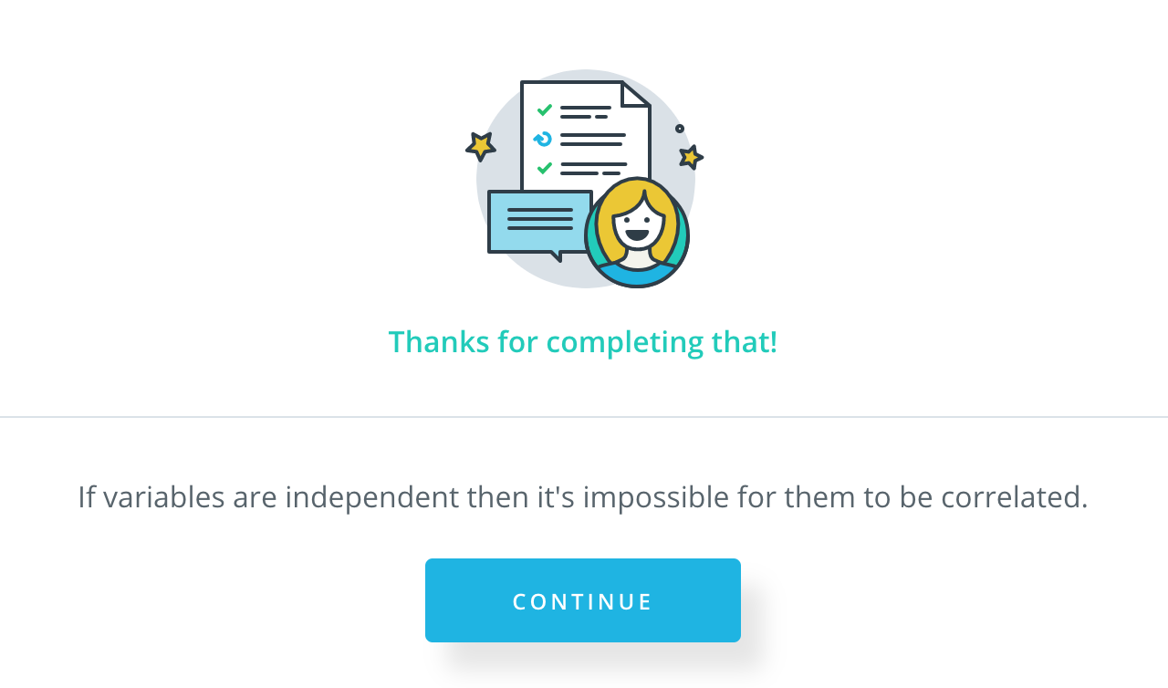

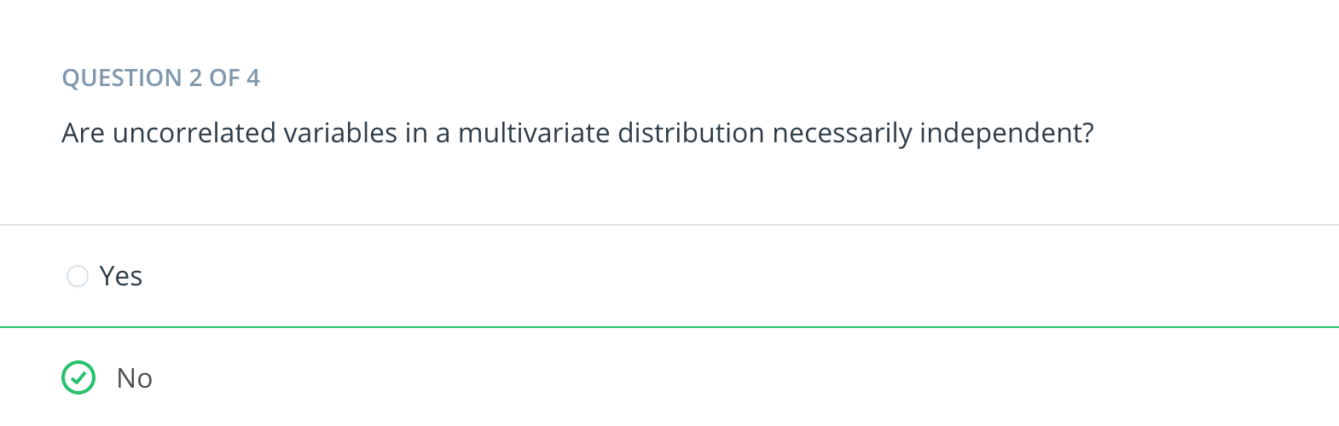

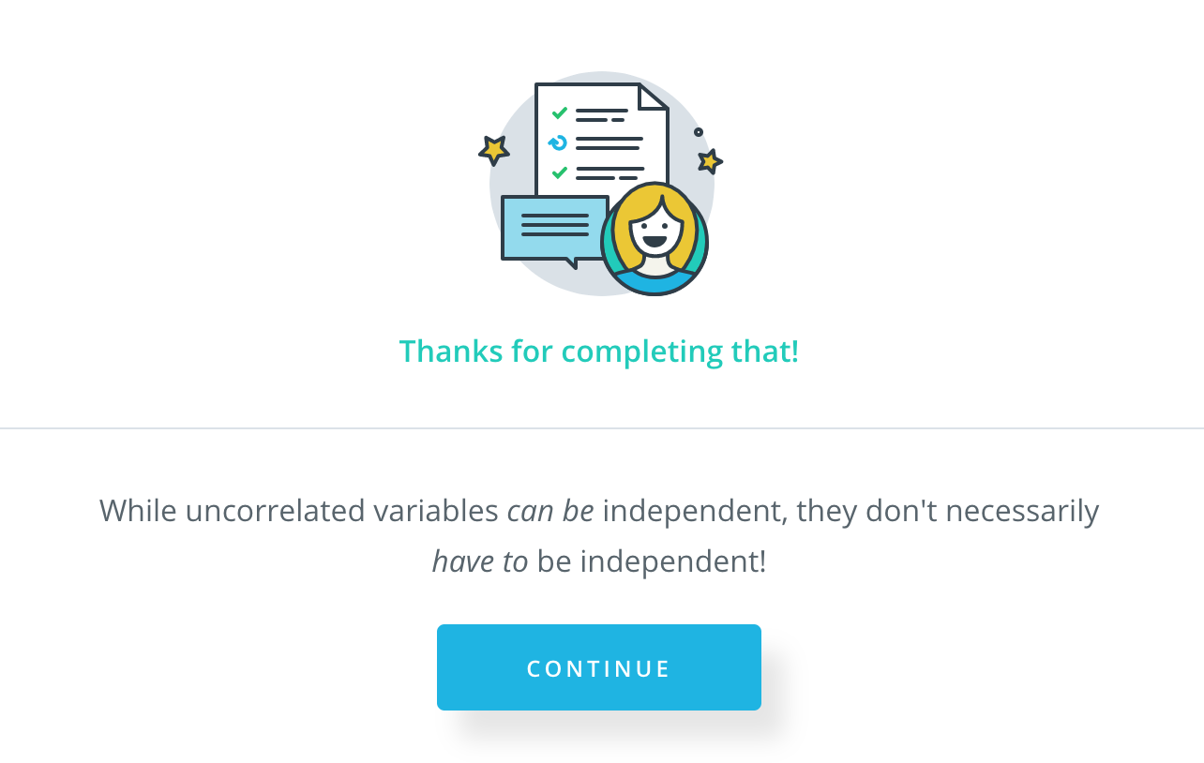

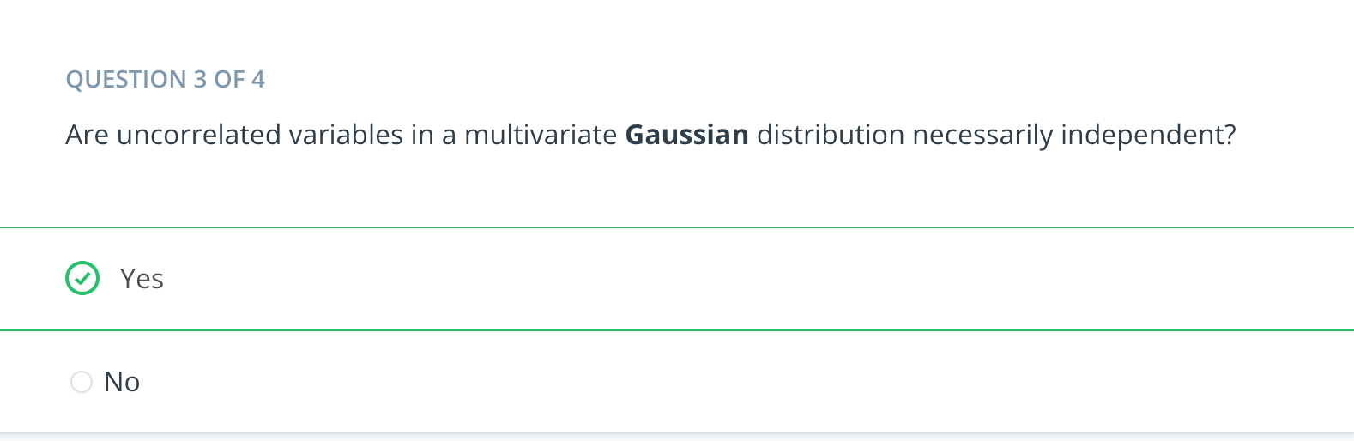

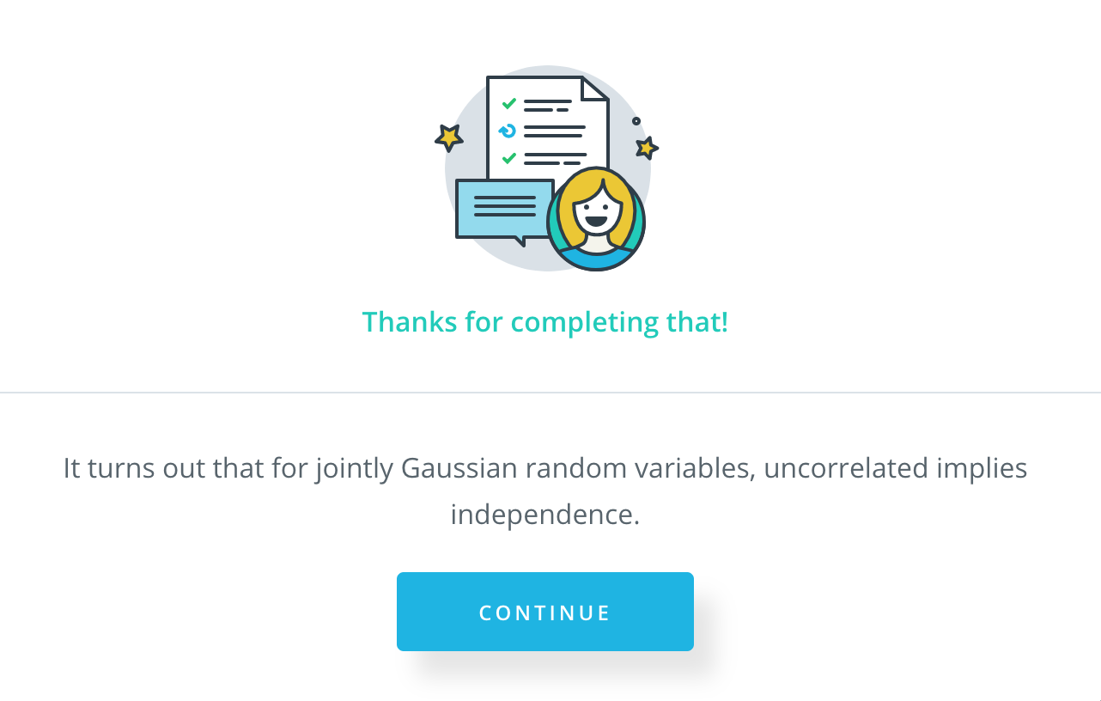

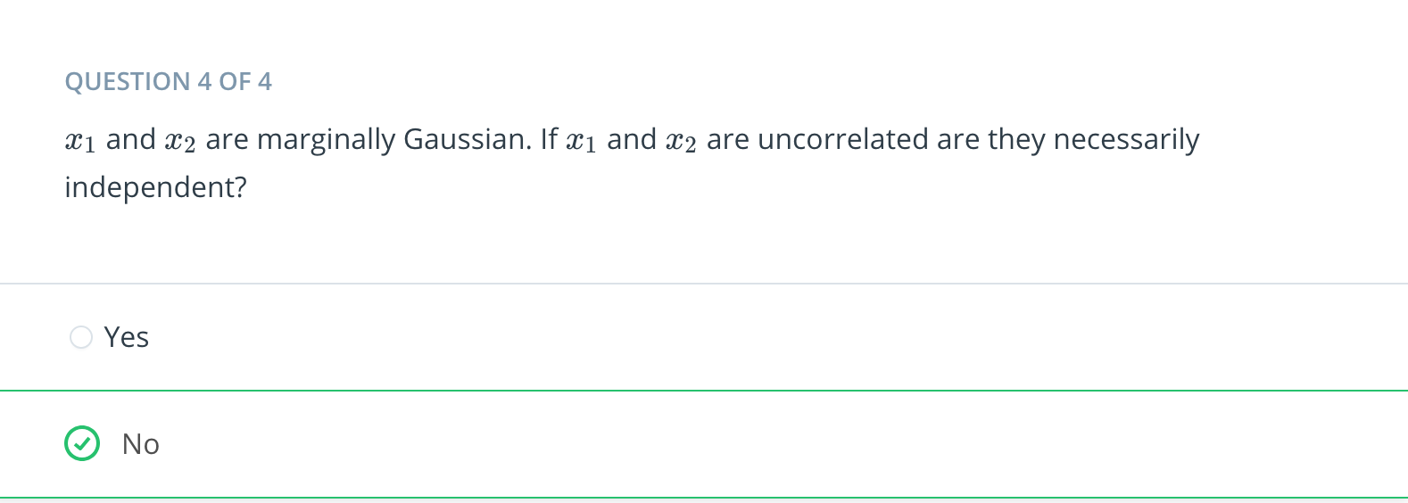

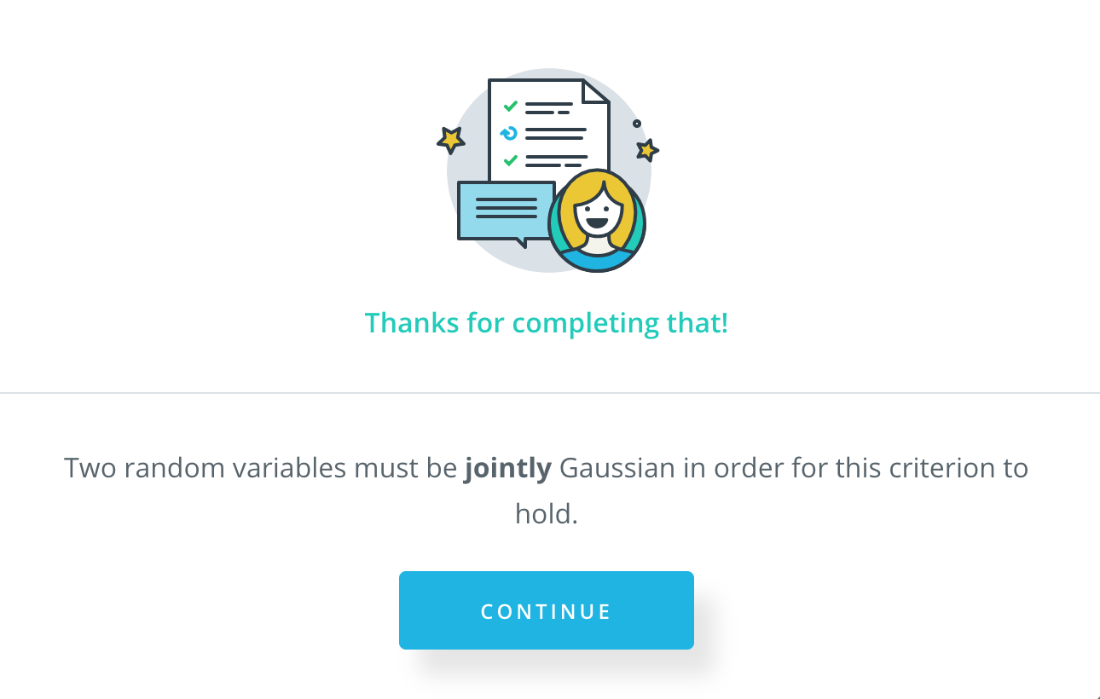

[18. Approaches to Estimation](https://classroom.udacity.com/nanodegrees/nd787/parts/a1505b23-c1aa-4bc6-a94c-d44d062d0209/modules/19b5af05-2ec7-491a-94db-1befc15d07c0/lessons/0aad84d9-ec84-42b6-8ed8-10d770055da4/concepts/2daa5f95-2ffd-4f38-8b8f-64d8e0c8ca54)

<https://www.youtube.com/watch?v=_7k7ZaRqII4>

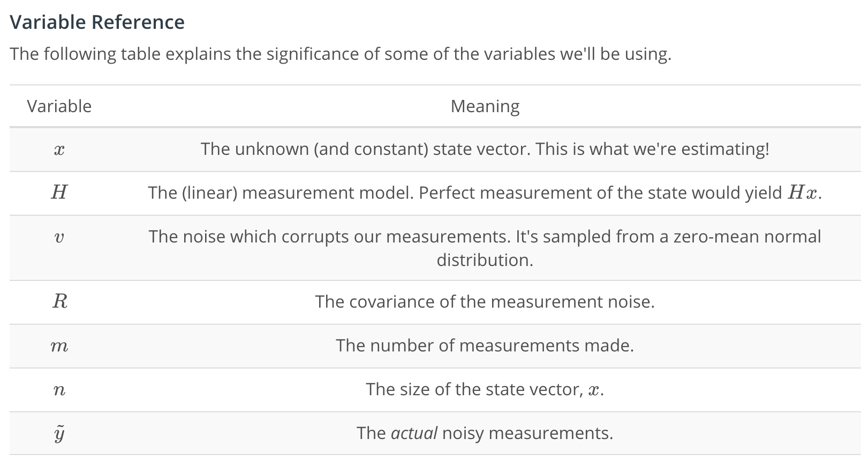

[19. Intro to Least Squares](https://classroom.udacity.com/nanodegrees/nd787/parts/a1505b23-c1aa-4bc6-a94c-d44d062d0209/modules/19b5af05-2ec7-491a-94db-1befc15d07c0/lessons/0aad84d9-ec84-42b6-8ed8-10d770055da4/concepts/c81f418e-dbe9-4dc5-972f-dc06ee93b195)

<https://www.youtube.com/watch?v=_V72SUDhIAw>

[20. Deriving the Maximum Likelihood Estimator](https://classroom.udacity.com/nanodegrees/nd787/parts/a1505b23-c1aa-4bc6-a94c-d44d062d0209/modules/19b5af05-2ec7-491a-94db-1befc15d07c0/lessons/0aad84d9-ec84-42b6-8ed8-10d770055da4/concepts/58886fd6-c8db-4ae7-88b9-bfbf92ed0fa0)

<https://www.youtube.com/watch?v=yQmtE0vWCQg>

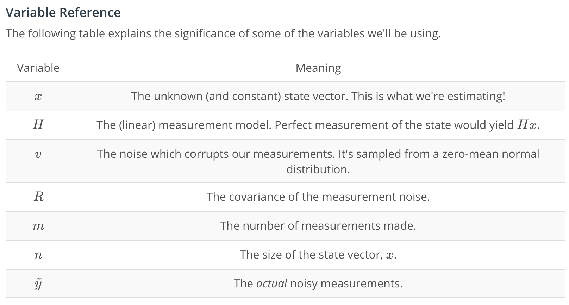

[21. Fitting a Line with Linear Least Squares](https://classroom.udacity.com/nanodegrees/nd787/parts/a1505b23-c1aa-4bc6-a94c-d44d062d0209/modules/19b5af05-2ec7-491a-94db-1befc15d07c0/lessons/0aad84d9-ec84-42b6-8ed8-10d770055da4/concepts/960275fc-0b55-49c8-a279-7a154460f951)

<https://www.youtube.com/watch?v=UfmjTc33wa8>

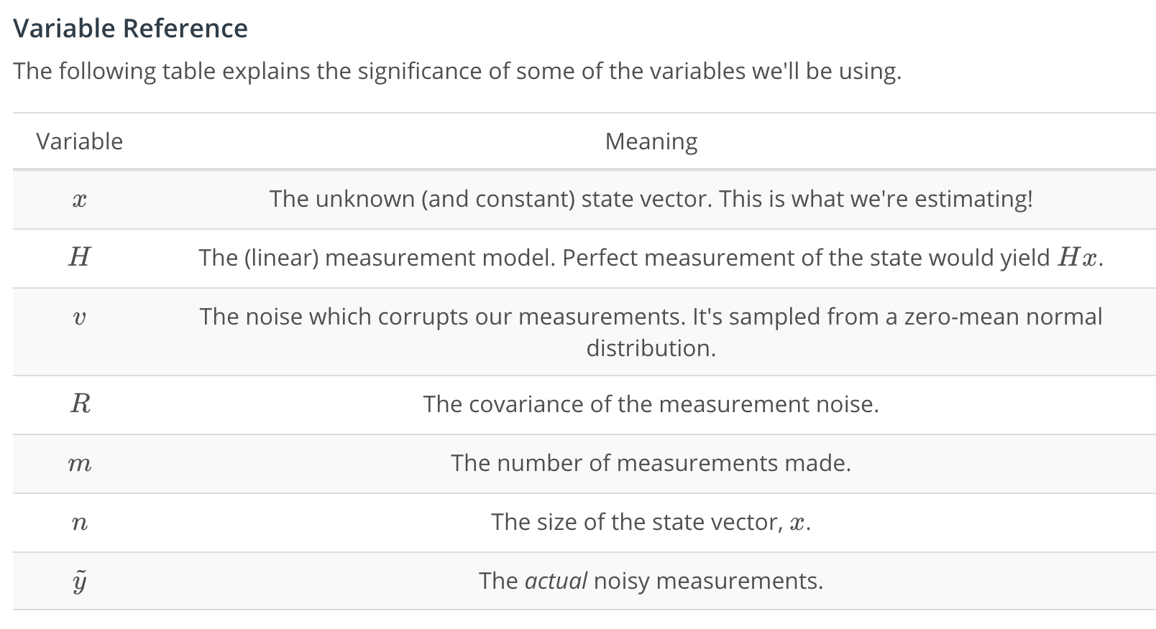

[22. Least Squares Notebook](https://classroom.udacity.com/nanodegrees/nd787/parts/a1505b23-c1aa-4bc6-a94c-d44d062d0209/modules/19b5af05-2ec7-491a-94db-1befc15d07c0/lessons/0aad84d9-ec84-42b6-8ed8-10d770055da4/concepts/53b1418e-378e-4656-b88c-a76b4429cd90)

[Least-Squares.ipynb](https://viewbb95dd3a.udacity-student-workspaces.com/notebooks/Least-Squares.ipynb)

[23. Recursive Estimation](https://classroom.udacity.com/nanodegrees/nd787/parts/a1505b23-c1aa-4bc6-a94c-d44d062d0209/modules/19b5af05-2ec7-491a-94db-1befc15d07c0/lessons/0aad84d9-ec84-42b6-8ed8-10d770055da4/concepts/7f3f9e49-fdec-447d-9817-480c3a47533c)

<https://www.youtube.com/watch?v=t1HvD3cqWUY>

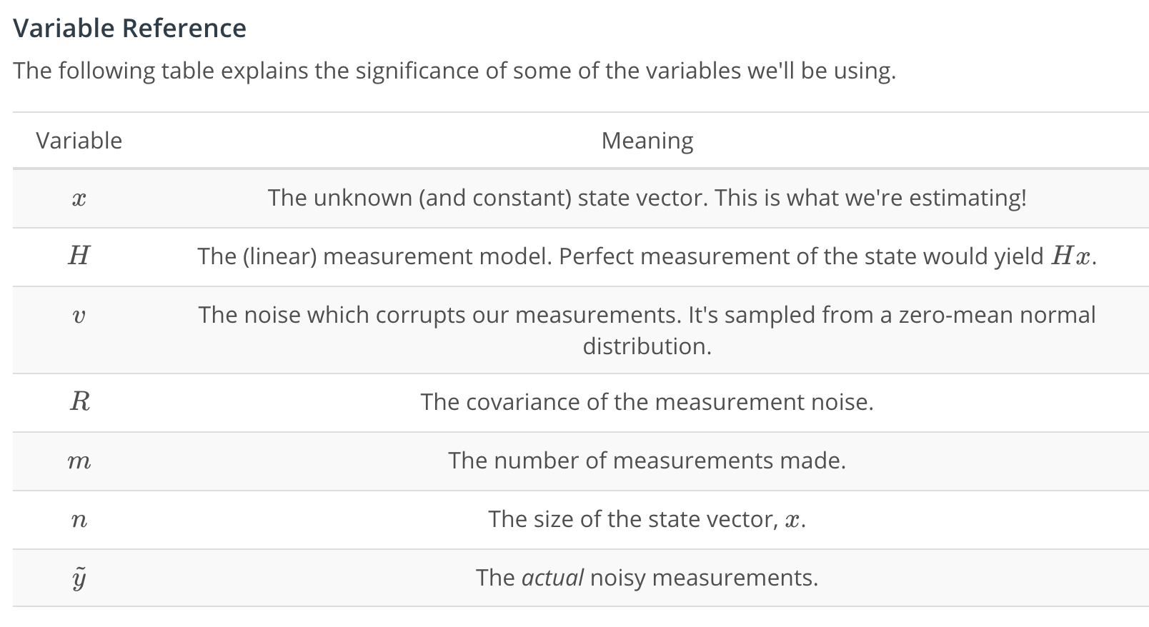

[24. Recursive Estimation Notebook](https://classroom.udacity.com/nanodegrees/nd787/parts/a1505b23-c1aa-4bc6-a94c-d44d062d0209/modules/19b5af05-2ec7-491a-94db-1befc15d07c0/lessons/0aad84d9-ec84-42b6-8ed8-10d770055da4/concepts/1f61b5ab-394a-4e31-ab1d-efa56171be9a)

[Recursive-Estimation.ipynb](https://view71a85f60.udacity-student-workspaces.com/notebooks/Recursive-Estimation.ipynb)

[25. The Problem with non-Linearities](https://classroom.udacity.com/nanodegrees/nd787/parts/a1505b23-c1aa-4bc6-a94c-d44d062d0209/modules/19b5af05-2ec7-491a-94db-1befc15d07c0/lessons/0aad84d9-ec84-42b6-8ed8-10d770055da4/concepts/fe2a0c37-c4eb-4602-8a2f-b856b4238684)

<https://www.youtube.com/watch?v=dcmLDW_ZSfw>

[26. Calculating the Jacobian](https://classroom.udacity.com/nanodegrees/nd787/parts/a1505b23-c1aa-4bc6-a94c-d44d062d0209/modules/19b5af05-2ec7-491a-94db-1befc15d07c0/lessons/0aad84d9-ec84-42b6-8ed8-10d770055da4/concepts/275ce5f6-c2fc-46f3-a4d4-19488527b3e5)

<https://www.youtube.com/watch?v=9q_oQOfjx5k>

[27. Non-Linear Least Squares Notebook](https://classroom.udacity.com/nanodegrees/nd787/parts/a1505b23-c1aa-4bc6-a94c-d44d062d0209/modules/19b5af05-2ec7-491a-94db-1befc15d07c0/lessons/0aad84d9-ec84-42b6-8ed8-10d770055da4/concepts/75e38444-7d9f-464e-a19d-6b7ac93419c5)

[Non-Linear-Least-Squares.ipynb](https://viewe1b17065.udacity-student-workspaces.com/notebooks/Non-Linear-Least-Squares.ipynb)

[28. Conclusion](https://classroom.udacity.com/nanodegrees/nd787/parts/a1505b23-c1aa-4bc6-a94c-d44d062d0209/modules/19b5af05-2ec7-491a-94db-1befc15d07c0/lessons/0aad84d9-ec84-42b6-8ed8-10d770055da4/concepts/111ac0b9-f63d-4f63-b922-aabf5c66ebbd)

# **Conclusion**

Congratulations! This lesson was a **quick** review of probability, so don't worry if you're feeling like some of those concepts still aren't 100% clear. If you feel like you could use some additional review, now would be a good time to explore some other resources.

## **Other Resources**

* [Kalman and Bayesian Filters in Python](https://github.com/rlabbe/Kalman-and-Bayesian-Filters-in-Python) - This is a **fantastic** resource. It's a GitHub repository containing a series of Jupyter notebooks which are meant to teach the intuition underlying Kalman Filters (something we'll discuss in lessons 3 and 4). But there are also some great notebooks covering more introductory topics like Gaussians and Multivariate Gaussians.
* [Udacity's Intro to Statistics Course, taught by Sebastian Thrun](https://classroom.udacity.com/courses/st101) - Browse through these lessons for a slower-paced explanation of topics like probability, conditional probability, Bayes' Rule, probability distributions, correlation, estimation, averages, variance, and normal distributions.